*IOT based Smart Agricultural System*

Shashank Naik   
*SE EXTC*  
*DJ Sanghvi* Mumbai, India  
  
Yash Doke  
 *SE EXTC*   
DJ Sanghvi  
Mumbai, India  
Varun Choudhary  
SE EXTC  
DJ Sanghvi  
Mumbai, India  
 Rujul Pawar  
SE EXTC  
DJ Sanghvi  
Mumbai, India

Smit Asher  
SE EXTC

DJ SanghviMumbai, India

Tanishq Patel

SE EXTC  
DJ Sanghvi  
Mumbai, India

# `Introduction

The agricultural sector faces numerous challenges, including climate change, water scarcity, and the need for increased productivity to meet growing global food demands. To address these challenges, there is a growing interest in leveraging modern technologies such as the Internet of Things (IoT) to develop smart agricultural systems. This project aims to design and implement a Smart IoT Agricultural System using ESP32 microcontroller along with various sensors and actuators to monitor environmental conditions, automate irrigation, and enhance overall farm management. The primary objective of this project is to create an integrated IoT-based solution that enables farmers to monitor key environmental parameters, automate irrigation processes, and optimize resource utilization in agricultural operations. By implementing this system, we aim to improve crop yields, conserve water, and promote sustainable farming practices.

# Components

1. ***ESP32 Microcontroller:***

The ESP32 is chosen for its powerful processing capabilities, built-in Wi-Fi and Bluetooth connectivity, and low power consumption.

It serves as the central processing unit of the system, responsible for data acquisition, processing, and communication with external sensors and actuators.

1. ***DHT11 Sensor:***

The DHT11 is a digital temperature and humidity sensor with a measurement range of 0-50°C for temperature and 20-90% for humidity.

It provides real-time data on temperature and humidity levels in the environment, essential for optimizing irrigation schedules and ensuring proper plant growth.

1. ***Rain Sensor***:

Rain sensors detect the presence and intensity of rainfall using conductive pads.

This sensor allows the system to automatically adjust irrigation schedules based on rainfall, thereby optimizing water usage and preventing overwatering of crops.

1. ***Water Level Sensor:***

Water level sensors come in various types such as float switches or ultrasonic sensors.

They monitor the water level in irrigation reservoirs, ensuring a consistent water supply for irrigation and preventing water shortages or overflows.

1. ***MQ2 Gas Sensor:***

The MQ2 gas sensor detects various gases including methane, propane, and carbon monoxide.

Gas sensors are crucial for safety and environmental monitoring, detecting gas leaks from storage tanks or agricultural machinery to prevent accidents and protect farm workers.

1. ***Relay Module:***

A relay module is used to control the operation of the water pump based on signals from the microcontroller.

It switches high-current loads such as the water pump on/off, enabling automated irrigation control according to soil moisture levels.

1. ***12V Motor and L298 Motor Driver***:

The 12V motor, powered by a 12-volt power source, drives the irrigation system.

The L298 motor driver regulates the speed and direction of the motor, allowing precise control of water flow and distribution in the field.

1. ***16x2 LCD:***

The 16x2 LCD module provides a user-friendly interface for displaying real-time data and system status.

Farmers can easily monitor environmental parameters, irrigation schedules, and system operations through the LCD display.

# System Architecture

The Smart IoT Agricultural System follows a hierarchical architecture comprising the following components and functionalities:

1. ***Data Acquisition***

The sensors continuously monitor environmental conditions, detecting changes in temperature, humidity, rainfall, water level, and gas concentrations.

1. ***Data Processing***

The microcontroller collects data from the sensors and processes it in real-time, applying predefined algorithms to determine the appropriate actions required based on the observed conditions.

1. ***Decision Making:***

Based on the processed data, the microcontroller makes intelligent decisions regarding irrigation management and environmental monitoring.

1. ***Actuator Control***

Based on the processed data, the microcontroller controls the operation of the actuators, such as activating the water pump for irrigation or adjusting motor speed for water distribution.

1. ***User Interaction***

Farmers can monitor system status and make necessary adjustments through the user interface provided by the LCD display, ensuring effective management of agricultural operations.

1. ***Continuous Monitoring and Adaptation:***

The Smart IoT Agricultural System operates in a continuous monitoring and adaptation loop, constantly collecting data, processing it, and adjusting irrigation processes and environmental monitoring based on the changing conditions.

This adaptive approach ensures efficient resource utilization, maximizes crop yields, and promotes sustainable farming practices.

# Technology Stacks and RESOURCES

***Hardware Components:***

* ESP32 or Arduino microcontroller for data processing and control.
* DHT11, rain sensors, water level sensors, and gas sensors for environmental monitoring.
* Relay modules, water pumps, and motors for actuation and control.
* LCD displays for user interface and feedback.

***Software Frameworks***:

* Arduino IDE for programming microcontrollers and interfacing with sensors and actuators.
* PlatformIO for managing project dependencies and libraries.
* MQTT broker for enabling communication between IoT devices and cloud platforms.
* Node-RED for building visual IoT applications and workflows.

***Cloud Platforms:***

* Cloud platforms such as AWS IoT, Google Cloud IoT, and Microsoft Azure IoT provide scalable infrastructure for hosting and managing IoT applications.
* These platforms offer services for data storage, analytics, and device management, enabling seamless integration with IoT devices and applications.

# REPORT

***Design Considerations***

During the system design phase, several considerations were taken into account to ensure optimal performance and reliability. Factors such as power consumption, connectivity, sensor placement, and environmental conditions were carefully evaluated to meet the project requirements. Additionally, data management practices and security measures were implemented to handle sensor data securely and protect against cyber threats.

***Implementation Methodology***

The implementation of the Smart IoT Agricultural System followed a structured approach, including the development process, testing procedures, and validation methods. Arduino IDE and PlatformIO were used for programming microcontrollers and managing project dependencies, while MQTT brokers facilitated communication between IoT devices.

***Future Directions and Potential Enhancements***

Looking ahead, there are several opportunities for further enhancing the Smart IoT Agricultural System. Integration with advanced technologies such as machine learning algorithms could enable predictive analytics and personalized recommendations for farmers. Expansion of sensor capabilities and incorporation of additional environmental parameters could provide more comprehensive insights into farm conditions. Collaboration with stakeholders and continued research and development efforts will be key to realizing the full potential of smart agriculture solutions.

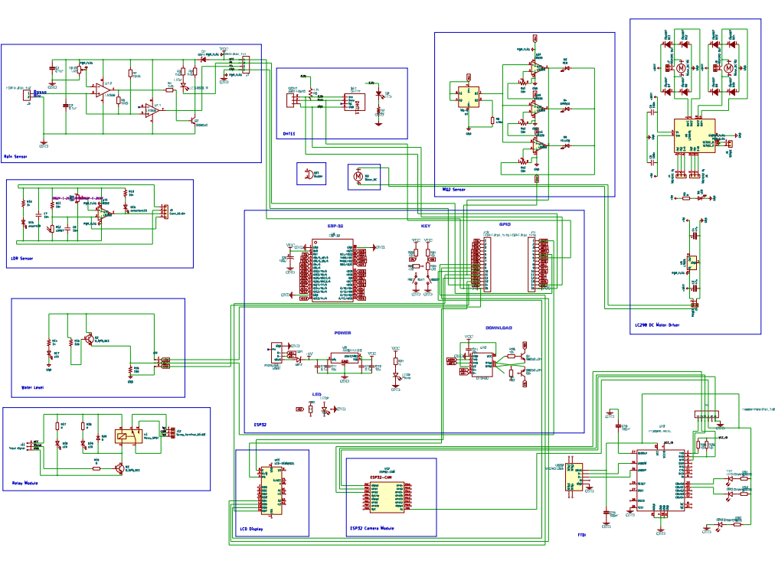

|  |  |  |  |
| --- | --- | --- | --- |
| *Component* | *Price* | *Component* | *Price* |
| ESP32 | 750/- | **Motor Driver LM298** | 250/- |
| ESP32 CAM | 475/- | **FTDI** | 150/- |
| DHT11 | 120/- | **12v DC motor** | 250/- |
| Rain Sensor | 150/- | **16x2 LCD** | 200/- |
| Soil Moisture | 120/- | **Buzzer** | 15/- |
| Water Level Sensor | 70/- | **Water Pump** | 50/- |
| Relay | 60/- | **MQ2** | 90/- |
| Connectors | 50/- | **Switch** | 10/- |
|  |  | ***TOTAL*** | **2810/-** |

# CONCLUSION

The journey of developing the Smart IoT Agricultural System has been enlightening, offering invaluable insights and key takeaways that shed light on the potential of modern technologies to revolutionize traditional farming practices. As we draw this project to a close, it's essential to reflect on the learnings gained and highlight the key takeaways that will guide future endeavors in smart agriculture:

***Understanding the Importance of Integration***:

Integrating various technologies such as IoT, sensor technology, and data analytics is essential for creating a cohesive and efficient smart agriculture system. The seamless integration of hardware components, software frameworks, and user interfaces enables effective monitoring, control, and optimization of agricultural processes.

***Embracing Innovation for Sustainability***:

Embracing innovation is crucial for promoting sustainability in agriculture. The Smart IoT Agricultural System demonstrates how technologies like sensor-based monitoring, automated irrigation, and data-driven decision-making can contribute to resource conservation, water efficiency, and sustainable farming practices.

***Empowering Farmers with Data:***

Data is a powerful tool that can empower farmers to make informed decisions and optimize farm management practices. By providing real-time data on environmental conditions, irrigation schedules, and crop health, the Smart IoT Agricultural System equips farmers with the insights they need to maximize crop yields and minimize resource wastage.

***Fostering Collaboration and Knowledge Sharing:*** Collaboration and knowledge sharing are essential for driving innovation and advancing the field of smart agriculture. Engaging with stakeholders, sharing best practices, and collaborating on research and development efforts will accelerate the adoption of smart agriculture solutions and address the challenges facing the agriculture sector.

***Continuous Improvement and Adaptation:***

The journey of developing the Smart IoT Agricultural System has underscored the importance of continuous improvement and adaptation. As technology evolves and new challenges emerge, it is essential to remain agile, embrace feedback, and iterate on solutions to meet the evolving needs of farmers and the agricultural industry.

***Empathy and User-Centric Design:***

Finally, empathy and user-centric design are critical for creating solutions that resonate with end-users and address their needs effectively. By prioritizing user experience, listening to feedback, and designing intuitive interfaces, we can ensure that smart agriculture solutions are accessible, impactful, and sustainable in the long run.

In conclusion, the Smart IoT Agricultural System project has been a testament to the transformative power of technology in agriculture. By leveraging innovation, collaboration, and a commitment to sustainability, we can unlock new opportunities and address the challenges facing the agriculture sector, ultimately contributing to a more resilient, efficient, and sustainable food system for generations to come.

Top of Form